Law + GLCM + Hu features + GLRLM. 10 fold cross validation used to calculate accuracy.

1. GLRLM (all angles); no PCA; classes 1&2 and 3&4 lumped
   1. Best classifier: KNN

Accuracy = **80.5%**

AUC = 0.81

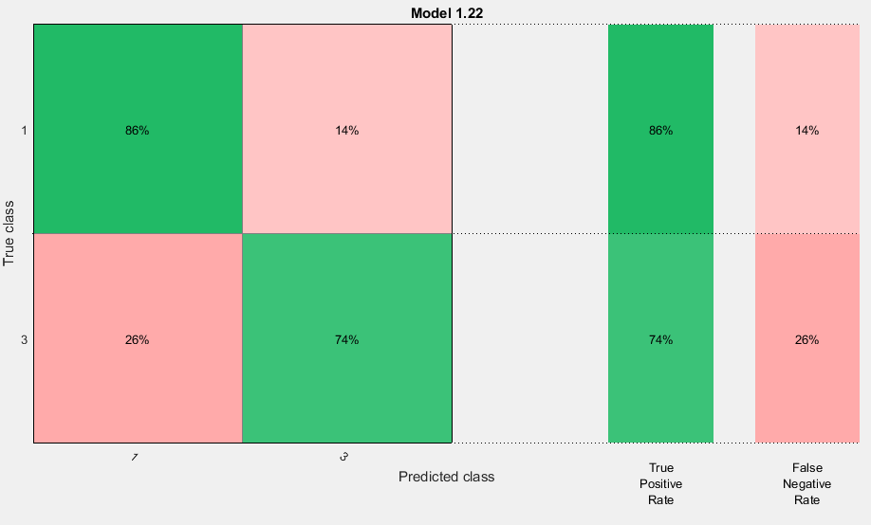

* 1. Best classifier: KNN

Accuracy = **81.8%**

AUC = 0.85

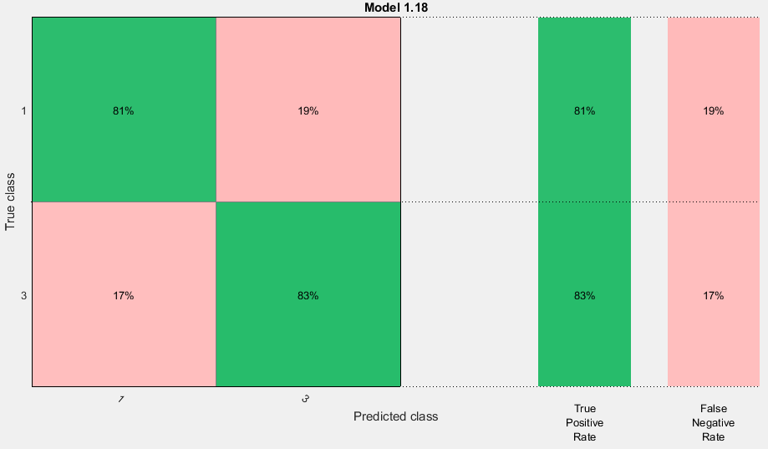

* 1. Best classifier: KNN

Accuracy = **80.5%**

AUC = 0.86

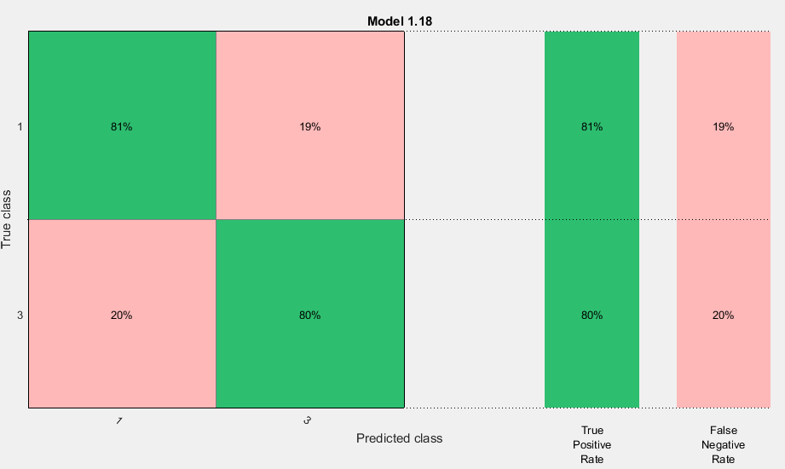

1. GLRLM (0°); no PCA; classes 1&2 and 3&4 lumped
   1. Best classifier: KNN

Accuracy = **77.9%**

AUC = 0.85

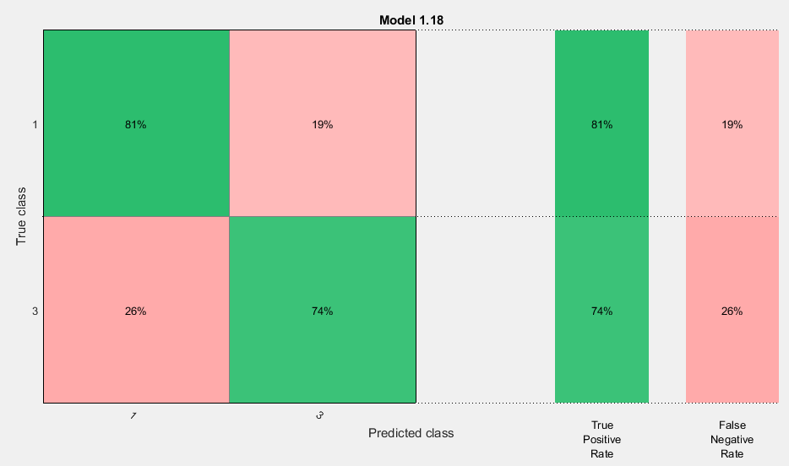

* 1. Best classifier: SVM

Accuracy = **76.6%**

AUC = 0.82

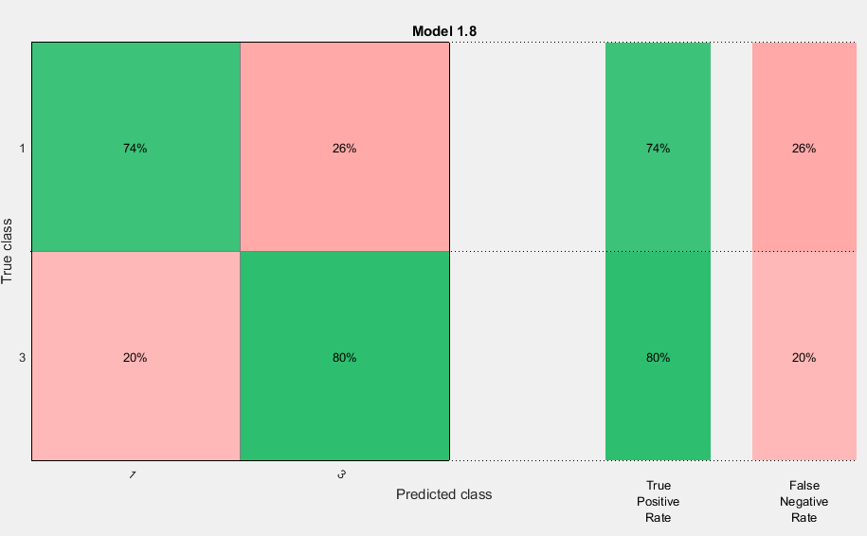

* 1. Best classifier: KNN

Accuracy = **80.5%**

AUC = 0.86

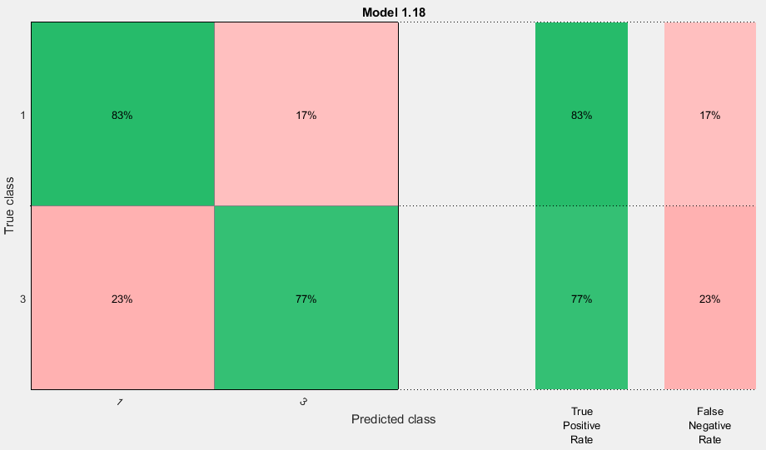

1. GLRLM (45°); no PCA; classes 1&2 and 3&4 lumped
   1. Best classifier: KNN

Accuracy = **83.1%**

AUC = 0.75

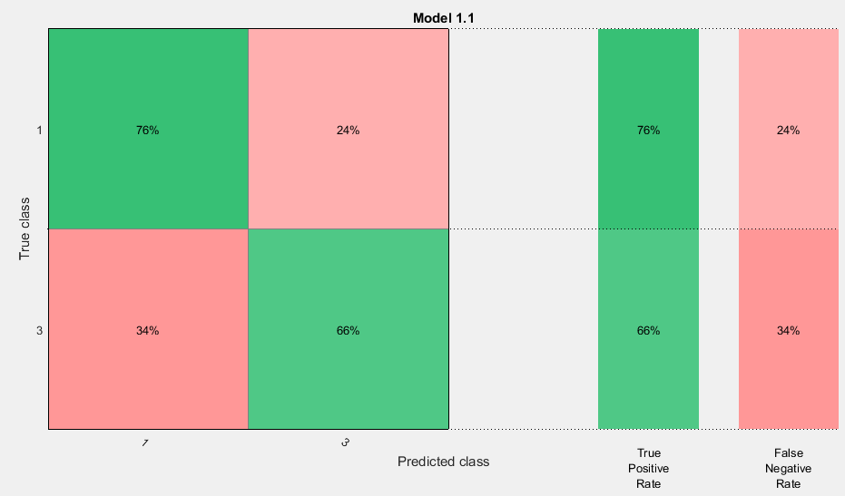

* 1. Best classifier: KNN

Accuracy = **81.8%**

AUC = 0.82

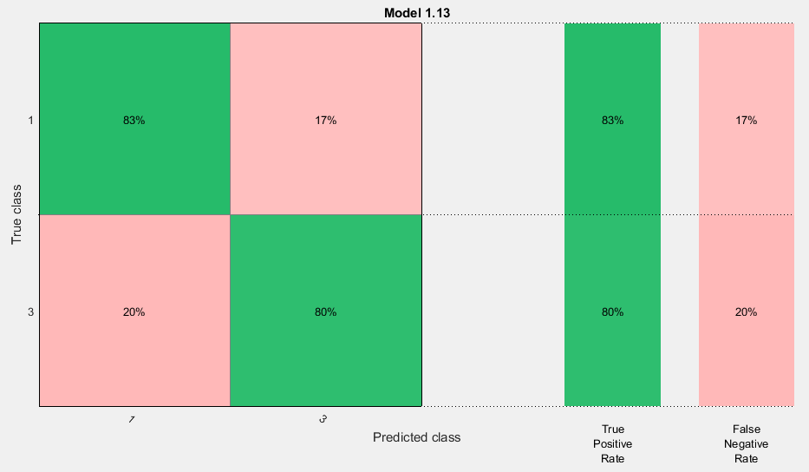

* 1. Best classifier: KNN

Accuracy = **84.4%**

AUC = 0.84

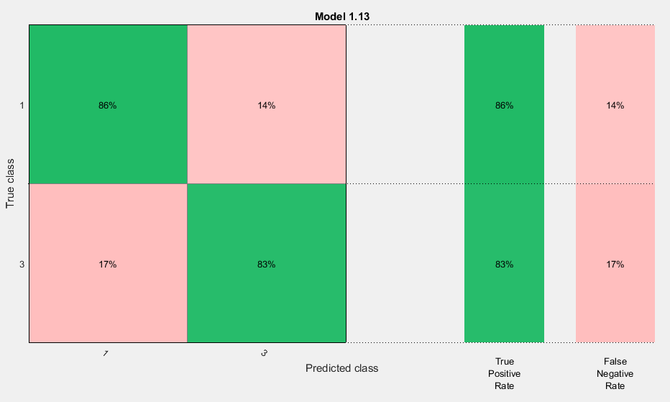

1. GLRLM (90°); no PCA; classes 1&2 and 3&4 lumped
   1. Best classifier: KNN

Accuracy = **71.4%**

AUC = 0.77

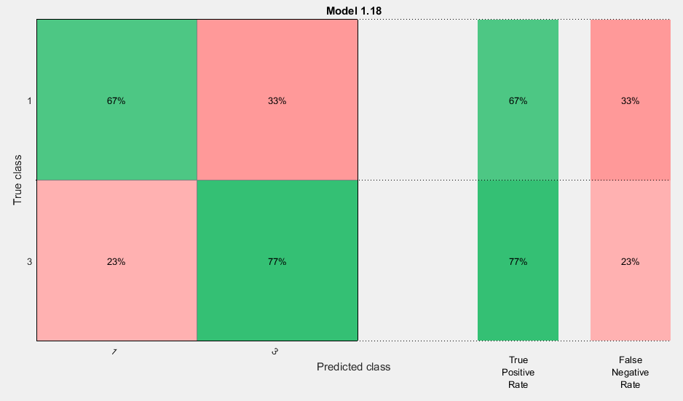

* 1. Best classifier: SVM

Accuracy = **75.3%**

AUC = 0.82

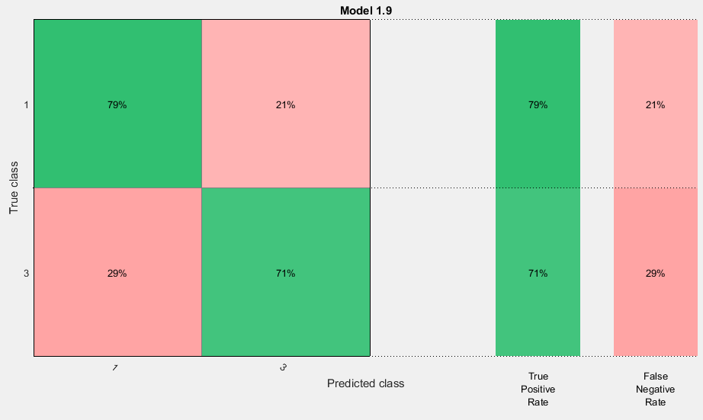

* 1. Best classifier: KNN

Accuracy = **74.0%**

AUC = 0.81

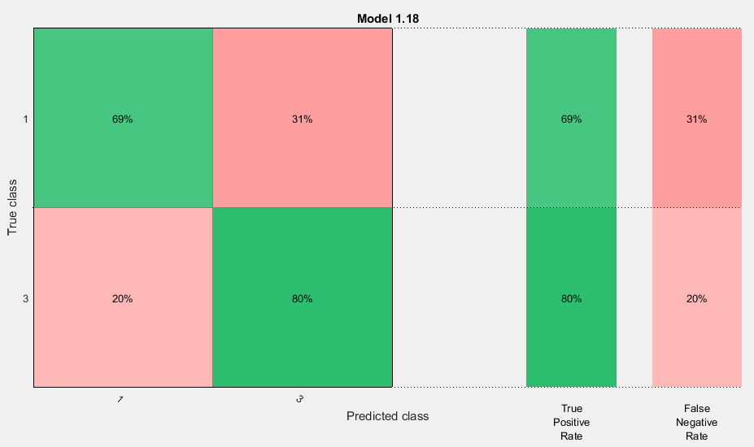

1. GLRLM (135°); no PCA; classes 1&2 and 3&4 lumped
   1. Best classifier: SVM

Accuracy = **74.0%**

AUC = 0.85

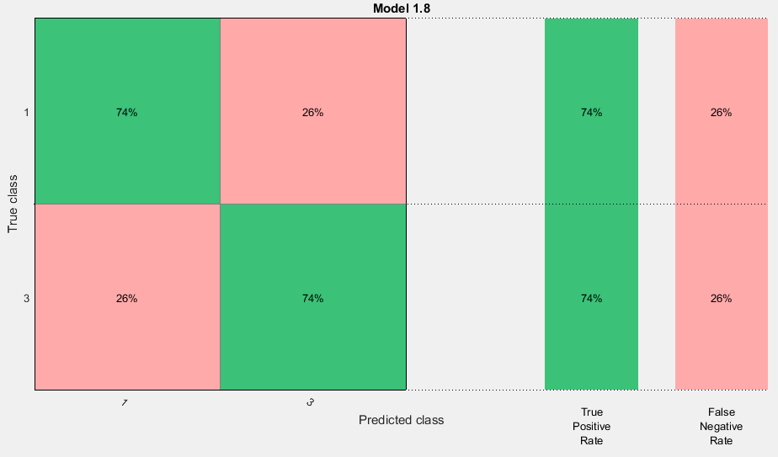

* 1. Best classifier: Ensemble

Accuracy = **71.4%**

AUC = 0.76

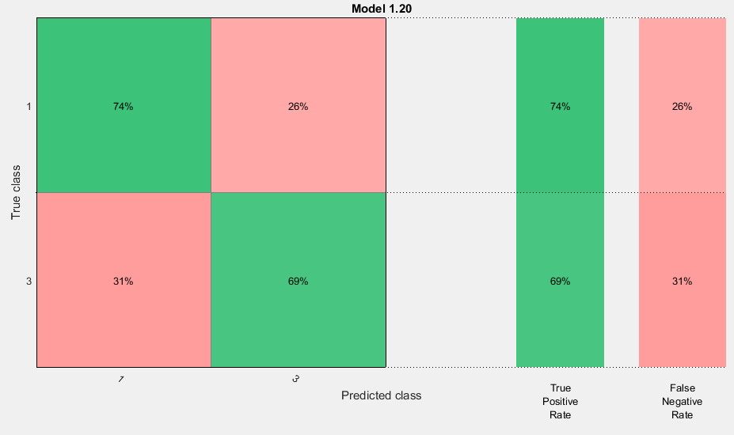

* 1. Best classifier: SVM

Accuracy = **75.3%**

AUC = 0.85

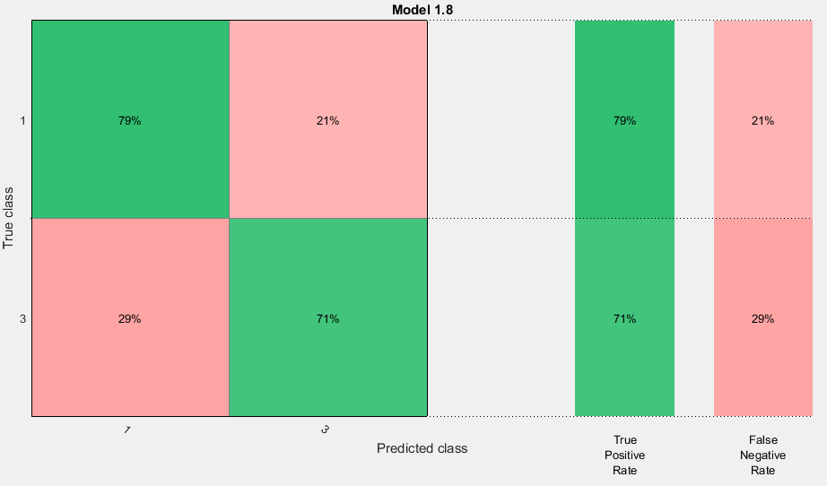

GLRLM features. 10 fold cross validation used to calculate accuracy.

1. GLRLM (all angles); no PCA; classes 1&2 and 3&4 lumped

Best classifier: Ensemble

Accuracy = **77.9%**

AUC = 0.86

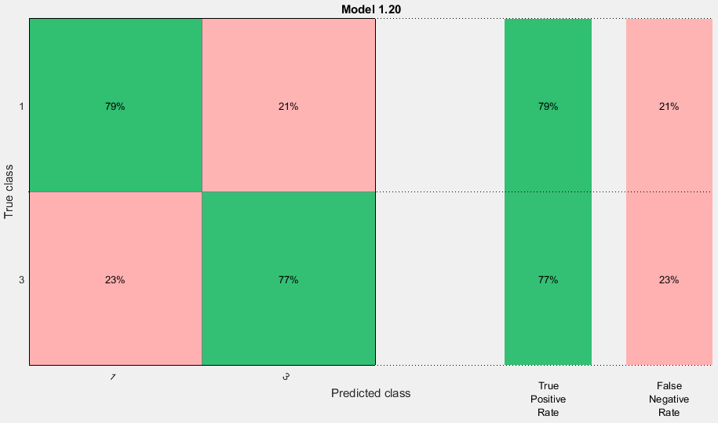

1. GLRLM (0°); no PCA; classes 1&2 and 3&4 lumped

Best classifier: SVM

Accuracy = **75.3%**

AUC = 0.78

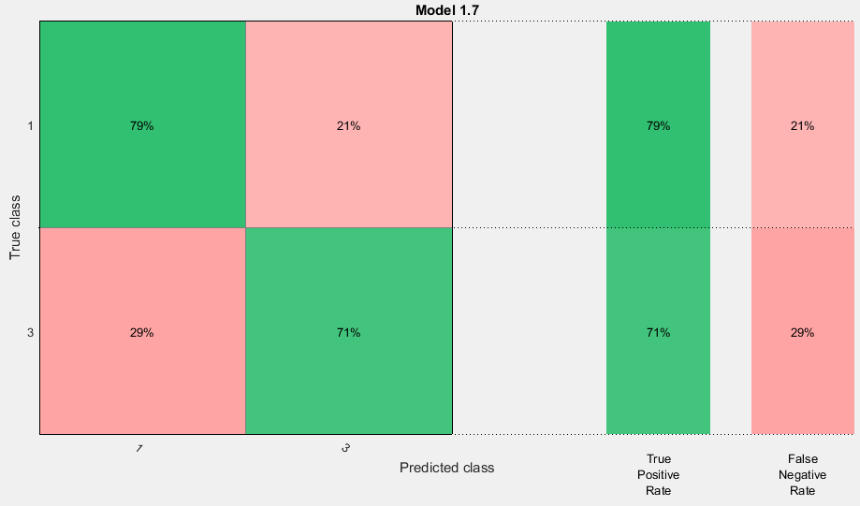

1. GLRLM (45°); no PCA; classes 1&2 and 3&4 lumped

Best classifier: Ensemble

Accuracy = **79.2%**

AUC = 0.85

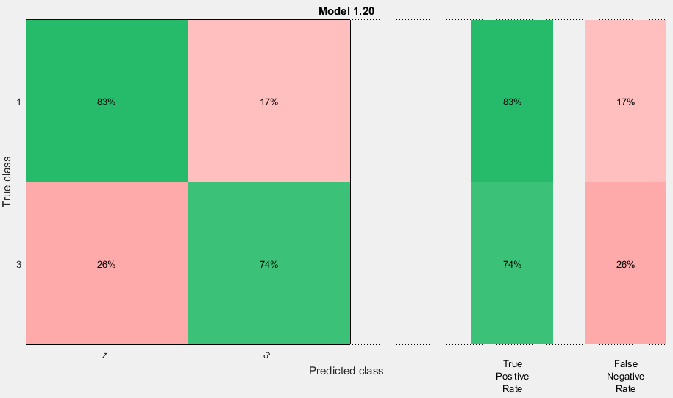

1. GLRLM (90°); no PCA; classes 1&2 and 3&4 lumped

Best classifier: SVM

Accuracy = **77.9%**

AUC = 0.84

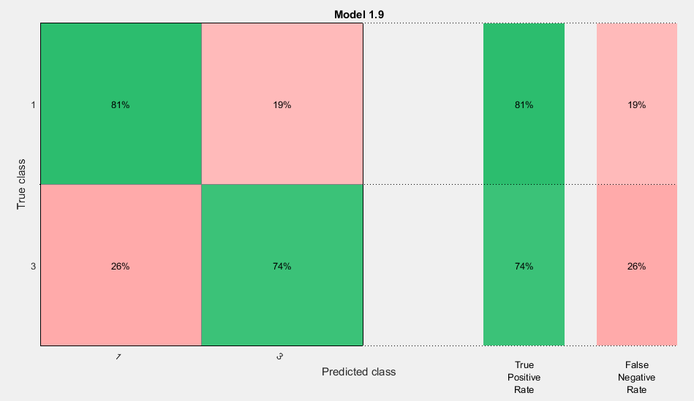

1. GLRLM (135°); no PCA; classes 1&2 and 3&4 lumped

Best classifier: SVM

Accuracy = **76.6%**

AUC = 0.81

